Project Report Implementation and Evaluation of Graph Theory

Algorithms Design and Analysis of Algorithms

Submitted By

Areeka Aijaz (17k-3913)

Tooba Shahid (17k-3731)

Abstract:

Implementing different algorithms on the graph from the input files. We need to compare the result for shortest path from different input files on different number of nodes.

Introduction:

implementing different algorithms on graph to compare the result for the shortest paths.

Proposed System:

The system first takes the input of the file.

It then displays the graph of the input file and asks which algorithm you want to implement.

And print the resultant graph along with the shortest path of the graph.

Experimental Setup:

The system takes the input of the file on which you want to implement algorithm and takes the input of which algorithm to be implemented.

Result and discussion:

|  |  |  |  |  |  |  |
| --- | --- | --- | --- | --- | --- | --- |
|  | Prim’s | Kruskal | Dijikstra | Bellman  Ford | Floyd  Warshall | Clustering  Coefficient |
| Input10 | 24.45 | 24.45 | 52.8 | 52.8 | 453.6 | 0.6583333333333333 |
| Input20 | 51.45 | 51.45 | 122.25 | 122.25 | 2274.9 | 0.48284685086155676 |
| Input30 | 86.6 | 86.6 | 162.9 | 162.9 | 6271.8 | 0.6980946493593553 |
| Input40 | 137.1 | 137.1 | 344.5 | 344.5 | 13504.2 | 0.7709709665090256 |
| Input50 | 133.05 | 133.05 | 260.4 | 260.4 | 15542.1 | 0.6114072786596005 |
| Input60 | 201.15 | 201.15 | 557.24 | 557.24 | 28674.6 | 0.7103363831898404 |
| Input70 | 195.7 | 195.7 | 475.3 | 475.3 | 36364.5 | 0.6854522329713372 |
| Input80 | 249.3 | 249.3 | 427.35 | 427.35 | 50689.6 | 0.7008658687965761 |
| Input90 | 287.1 | 287.1 | 765.3 | 765.3 | 65643.0 | 0.7858374185184407 |
| Input100 | 304.5 | 304.5 | 693.149 | 693.149 | 80038.79 | 0.6994231953515829 |

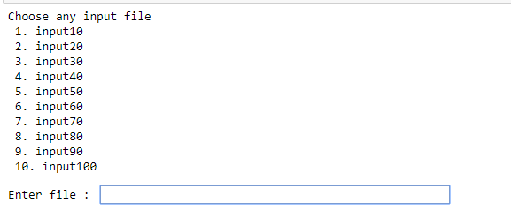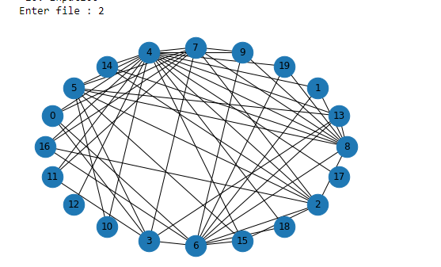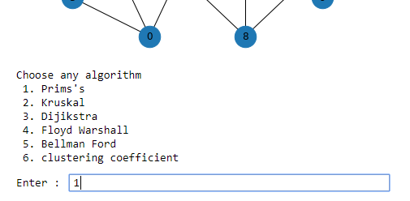

Conclusion:

From the above observation , prim’s algorithm gives the minimum shortest path value for the graph

References

1. Anany V. Levitin. 2006. *Introduction to the Design and Analysis of Algorithms (2nd Edition)*. Addison-Wesley Longman Publishing Co., Inc., Boston, MA, USA.